**Lab no 10**

**Functions**

**Name**  Zahra dua

**Sapid** 64880

**Subject**  programming fundamental

**Question 1:**

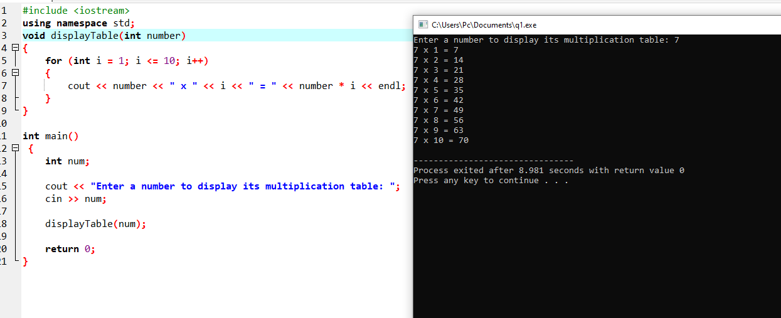

**Question 2:**

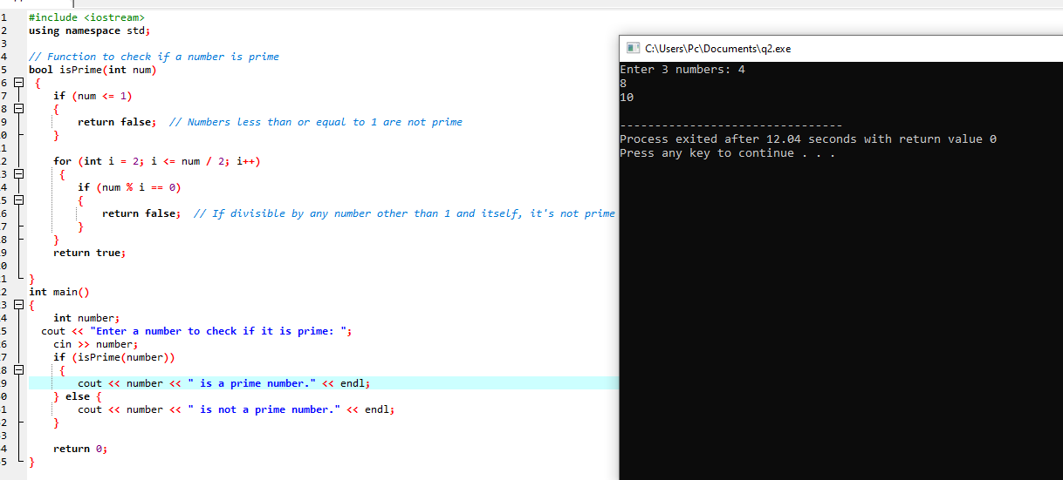

**Question 3:**

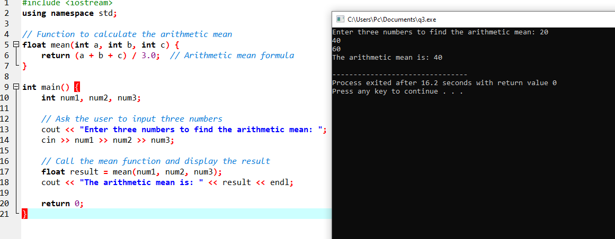

**Question 4:**

